# Technical Team Terms of Reference

On each site the following details need to be monitored:

1. Litter
2. Deadwood
3. Above ground biomass
4. Soil carbon
5. Biodiversity
6. Noors coverage

In addition, an allometric equation for noors (*Euphorbia coerulescens*) needs to be derived, in order to allow the estimation of noors coverage in all sites. (C4 EcoSolutions can undertake this work if required.)

The methodology for measurement of the variables is described in the project document, and the variables to be measured and recorded as well.

## Plot demarcation

1. Use the GPS coordinate specified to demarcate the south-western corner of the sampling plot. Drive an iron stake into the ground as a permanent marker.
2. Measure a 10m x 10m plot, and mark each of the corners with permanent markers. Sampling will be undertaken within this plot, within the sub-plots on the western edge (marked M1 to M10 in Figure 1), and along transects that intersect at the central point of the plot.

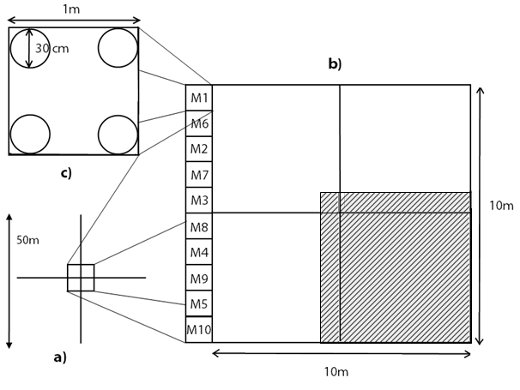

Figure 1: Diagrammatic representation of monitoring sites. a) Each site will comprise a 10m x 10m area, with two 50m long transects for deadwood monitoring bisecting the site; b) monitoring of above ground biomass will be carried out by measuring CBSA of P. afra and E. coerulescens plants in the site. Nested sub-plots (6m x 6m - shaded) will be used for monitoring the growth of offspring plants, and will be used instead of the full plots once stem density becomes too high; and c) litter monitoring will be carried out in peripheral 1m x 1m plots, since removal of litter from P.afra would affect the rate of growth of the stand (due to its method of vegetative propagation). Litter measurements will be gathered from 30cm radius circles in the corners of the litter plots, and no litter plot will be used twice. The letters in the boxes correspond to the monitoring period in which they will be used (ie M1= monitoring period 1, M2 = monitoring period 2, etc)

## Litter sampling

1. Litter sampling takes place within the northernmost of the peripheral sampling points, designated M1 on the diagram.
2. Place a 30 cm radius circular frame, in one corner of the designated peripheral plot.
3. All litter (leaves, fruits, small wood < 5 cm in diameter) falling inside the frame is collected.
4. Repeat for each of the four corners of M1, combining the litter into a single sample.
5. Record the weight of the litter.
6. Oven dry the sample at 60 oC until it reaches a constant mass.
7. Weigh the dry sample.

Variables to be recorded: Wet litter mass, dry litter mass.

## Deadwood sampling

Deadwood comprises two components: trees that are dead, but remain standing, and fallen trees and branches on the ground. Both of these need to be measured for dead *P. afra* ONLY .

1. Measure the basal diameter of all standing deadwood.
2. For each dead tree or stump, record which of the following decomposition classes it falls under:
   1. tree with branches and twigs that resembles a live tree (except for leaves);
   2. tree with no twigs but with persistent small and large branches;
   3. tree with large branches only; and
   4. bole only, no branches.
3. Establish two 50m lines bisecting the plot and intersecting in the centre of the plot.
4. Using calipers, measure the diameter of all lying dead wood (≥5 cm) that intersects each of the transects, and assign each piece to one of the following density states:
5. Sound;
6. intermediate; or
7. rotten.

Variables to be recorded: Basal diameter and decomposition class of all standing dead *P. afra* plants; diameter and density state of all lying dead *P afra* that intersects the transects.

## *Portulacaria afra* sampling

1. Demarcate the 6 m x 6 m nested sub-plot shaded with cross-hatching in Figure 1.
2. Measure the diameter of each P. afra stem within the entire 10 m x 10 m sampling site with digital calipers at ground level.
3. Once a stem has been measured, mark it with a non-damaging marker (piece of thread, spot of paint, felt-tip marker, etc) to prevent the double-counting of stems.
4. For all sampled plants, note whether it falls within the demarcated 6 m x 6 m sub-plot.

Variables to be recorded: diameter of all *P. afra* stems at ground level; whether each stem falls within the nested 6m x 6m sub plot.

## Biodiversity sampling

The biodiversity sampling looks at two different components, for which there are different measurement methods.

1. **Shrubs and trees** are measured along the 50m transects that have been established for measuring deadwood.
2. For each intersecting tree or shrub, record:
3. The species (if the species is not known, differentiate species with individual signifiers such as “Tree A”, “Shrub x”, and use them consistently); and
4. the length of the canopy cover of the plant along the transect.
5. Ignore overlaps of the same species, but record the count. If differing species overlap, count the entire cover for both plants.
6. **Grasses and forbs** are measured using quadrats.
7. Place a 2m x 2m quadrat randomly within the 10m x 10 m permanent plot.
8. Within the quadrat, measure and record all species of forbs and grasses.
9. For each species, include a count of the number of individuals, and an estimate of the cover of the species within the plot.
10. Repeat the quadrat measurements for two more random sites within the permanent plot.

Variables to be recorded: Number of species, individuals and canopy cover of each species along the transect and within each quadrat.

## Soil sampling

1. 5 sample plots are to be located within 2m of each of the corners within the 10 m x 10 m permanent monitoring site, as well as the centre of the site.
2. A sixth core for bulk density calculation should be made adjacent to one of the five sample cores.
3. Before excavation, clear all leaf litter and live plant material.
4. Use a soil corer to remove soil to a depth of 30 cm from each of the sample plots.
5. Combine these 5 soil samples into a single aggregated sample by mixing well in a single bag.
6. Determine the volume of the excavated holes by carefully filling them with sand of known bulk density.
7. Wet sieve the combined sample through a 2mm sieve, and discard the coarse (rock) fraction.
8. Oven-dry the sample at 60o C until it reaches a constant mass.
9. Record the weight of the dry sample.
10. Send 200g of the sample to Bemlab for analysis for organic carbon.
11. Send replicate samples every 20 samples (i.e. another 200 grams from every 20th sample) to Bemlab. Give the replicates a different name e.g. R1, R2 and record on a piece of paper and in excel what R1, R2 etc. refers to. These replicates are to check up on Bemlab, and ensure that they give us reproducible results
12. In order to calculate the bulk density, wet sieve the bulk density core with a 2 mm sieve, retaining the rock component.
13. Measure the volume of the coarse fraction by placing it into water and measuring the displacement.
14. The bulk density of the soil is calculated as the oven dry weight of the soil core divided by the core volume after discounting the volume of the coarse fraction.

Variables to be recorded: organic carbon component of soil, bulk density.

## *Euphorbia coerulescens* sampling

1. Measure the diameter of each *E. coerulescens* stem within the entire 10 m x 10 m sampling site with digital calipers at ground level.
2. Measure the height of each stem.
3. Measure the circumference of each clump of stems at a height of 30 cm.
4. Once a stem has been measured, mark it with a non-damaging marker (piece of thread, spot of paint, felt-tip marker, etc) to prevent the double-counting of stems.

Variables to be recorded: diameter of all *E. coerulescens* stems at ground level; whether each stem falls within the nested 6m x 6m sub plot.